Name:  Teacher: | ____________________________________  ________________ |  | Date:_________
 | Year 10 Mathematics  SCORE:  / 29  Mini test 5  Topic – Trigonometry  Full working out MUST be shown to get full marks for each question.
Total Time: | 35 minutes
Weighting: | 5 %
Equipment: | To be provided by the student: Pens and Pencils, scientific calculator, ruler and a A4 page of notes.

1. Multi choice; circle the correct answer: [8 marks]
I) What is the name for the side y in this triangle?
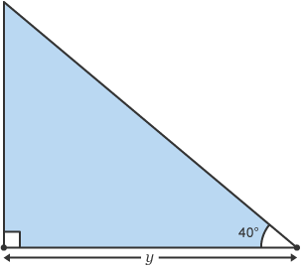
(A) Opposite (B) Adjacent (C) Hypotenuse

II) Which trigonometric ratio should be used to find the length of the adjacent side?
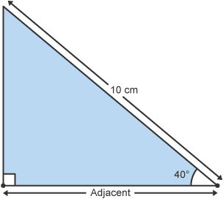
(A) Sin (B) Cos (C) Tan

III) Which trigonometric ratio calculates the sin of x?

(A)
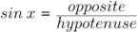

(B)
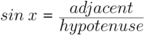

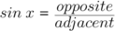
(C)

IV) Which trigonometric ratio should be used to find the length of y?
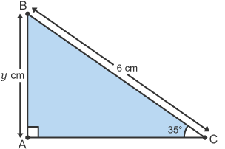
(A)

(B)

(C)

V) Which calculation shows the correct working to find y?
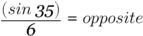
(A) 6 × sin 35 = opposite (B) sin (35 × 6) = opposite (C)

VI) What is the length of y?
(A) 10.46 cm (B) 3.44 cm (C) - 0.5 cm

VII) Which calculation shows the correct working to find the size of angle x?
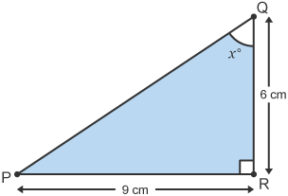
(A)
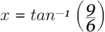
(B)
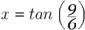

(C)
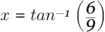

VIII) What is the size of angle x?
(A) 33.7° (B) 0.03° (C) 56.3°

Short answers:

2. Solve These Trigonometry problems using the Tan Ratio: [3,3]

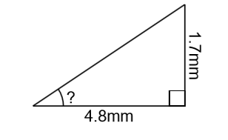
(I)

(II)

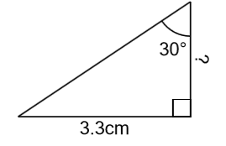

3. Solve This Trigonometry problems using the Sin Ratio: [3]

(I)
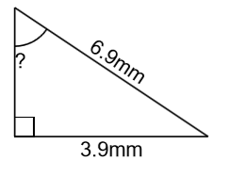

4. Solve This Trigonometry problems using the Cosine Ratio: [3]

(I)
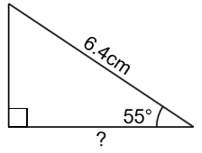

5. Solve the following worded problem:

(I) A ladder 5 m long, leaning against a vertical wall makes an angle of 65˚ with the ground. How high on the wall does the ladder reach? [5]

(II) A 25m tall flagpole casts a 42m shadow. What is the angle that the sun hits the flagpole? [4]
